**VISVESVARAYA TECHNOLOGICAL UNIVERSITY**

**JNANA SANGAMA, Belagavi-590018, Karnataka**

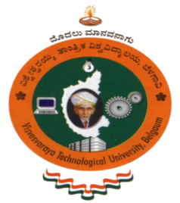

**PROJECT REPORT   
ON**

**INTELLIGENT DRIVER ASSISTANCE SYSTEM**

***Submitted in partial fulfilment of the requirements for the award of degree   
in***

**Bachelor of Engineering in Electronics and Communication**

***Submitted by***

**LOKESH V 1SK13EC017**

**SHREYAS M 1SK13EC054**

**T RAKESH 1SK13EC058**

***Under guidance of***

**Prof. Mamatha R**

**Assistant Professor**

**

**Department of Electronics and Communication Engineering**

**Govt. Sri Krishnarajendra Silver Jubilee Technological Institute**

**K R Circle, Bangalore – 560 001**

**2016 – 2017**